

# ***Project details:***

* ***The used programming language***
* ***The purpose of the document***
* ***The description of the program***

***(The used programming language: CPL)***

* **C** is a general-purpose programming language that is extremely popular, simple, and flexible to use.
* It is **a** **structured programming language** that is machine-independent and extensively used to write various applications, **Operating Systems like Windows, and many other complex programs like Oracle database, Git, Python interpreter, and more.**
* It is said that **'C'** is a **god's programming language.**
* One can say, **C** is a base for the programming.
* If you know **'C'**, you can easily grasp the knowledge of the other programming languages that uses the concept of **'C'** It is essential to have a background in computer memory mechanisms because it is an important aspect when dealing with the C programming language.

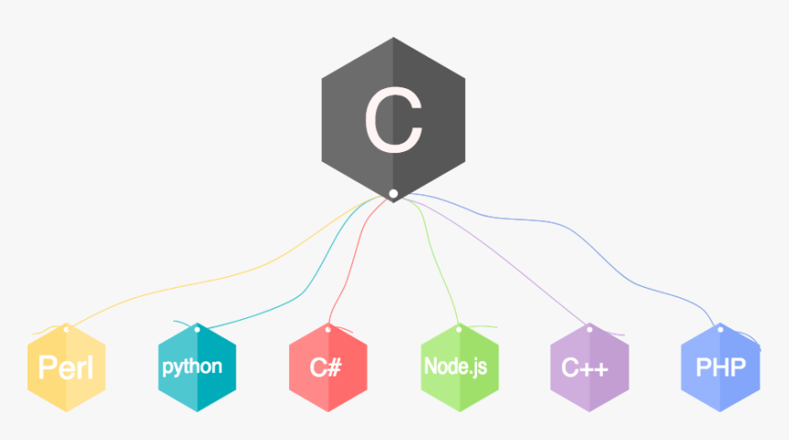

***(The purpose of the document)***

* The purpose of this document is to describe the code of the program with the help of code snippets to make it easily read and understood.



***(The description of the program)***

* There are 2 scenarios in this document:

1. **Multi-choice encryption and decryption program**
2. **SIC’s Enigma**

**Multi-choice encryption and decryption program**

* This program is based on **3 encryption and decryption techniques** that enable the user to choose the algorithm he wants every time until he decides to stop the program by himself.
* This program consists of group of functions which are:
* **Caesar Function**
* **Reverse Function**
* **Decryption Function**
* **Main function**

**Reverse Function**

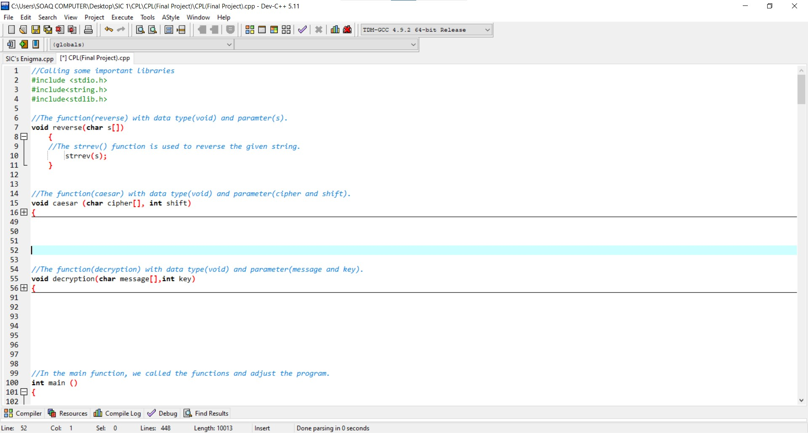

* First, we called some important libraries to help us in writing the program which are:
* **Stdio.h (Standard input output hidden library)**
* **String.h (String hidden library)**
* **Stdlib.h (Standard library (hidden))**
* **The Reverse function** aims to reverse the string entered by the user as one of algorithms used in **encryption and decryption techniques.**
* It reverses the array **(s).**

**Caesar Function**

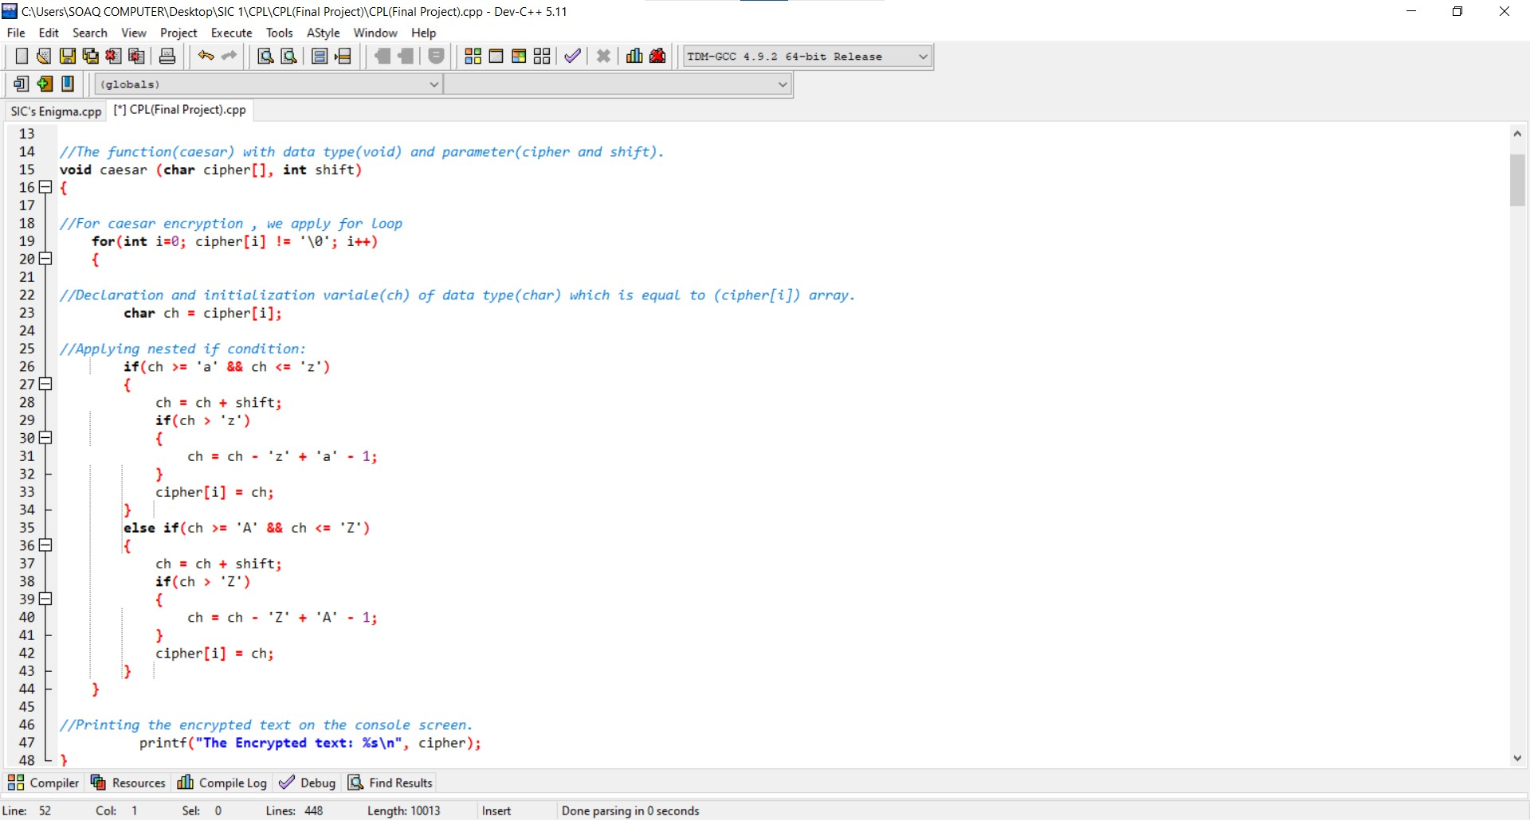

* **The Caesar function** aims to encrypt the string entered by the user by using Caesar technique.
* **Caesar technique** is based on **shifting the letters (+ or -)** and applying if conditions in some cases to make sure that the operation is correct.
* After that, the decrypted text is printed on the console screen.

**Decryption Function**

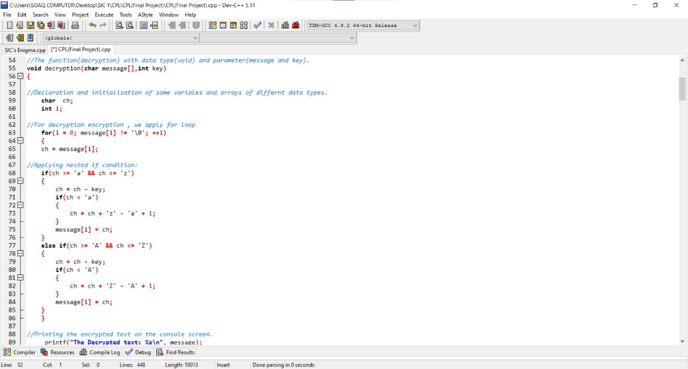

* **The Decryption function** aims to decrypt the string entered by the user by using Caesar technique.
* **Caesar technique** is based on **shifting the letters (+ or -)** and applying if conditions in some cases to make sure that the operation is correct.
* After that, the decrypted text is printed on the console screen.

**Main Function**

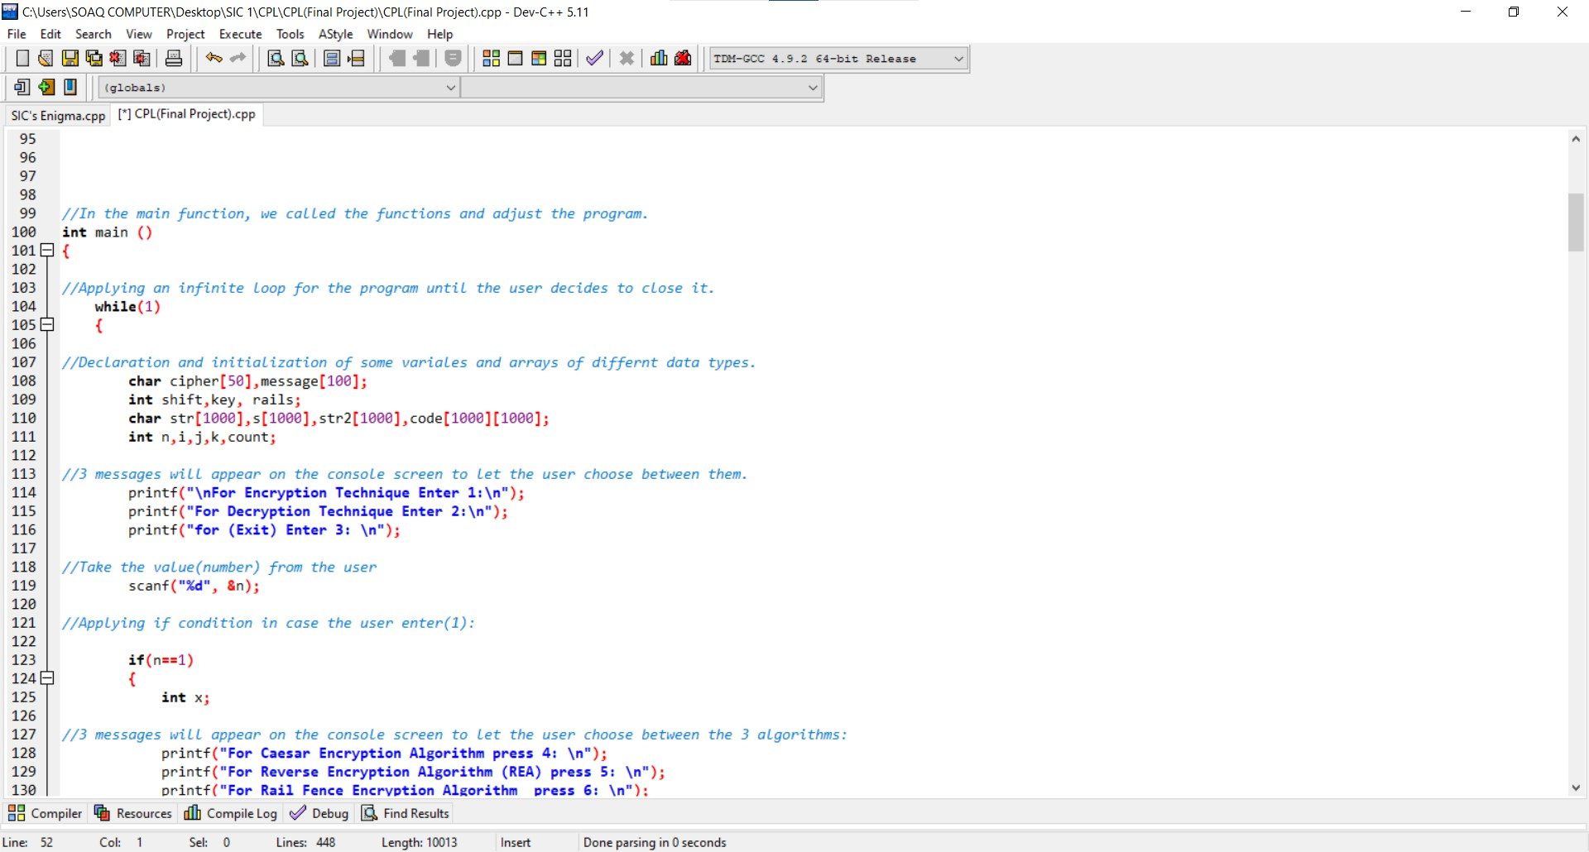

* In this function, we called the other functions and adjust the program.
* First, we apply infinite loop and inside it:
* We declared and initialized some variables.
* Print some messages.
* Take an input from the user.

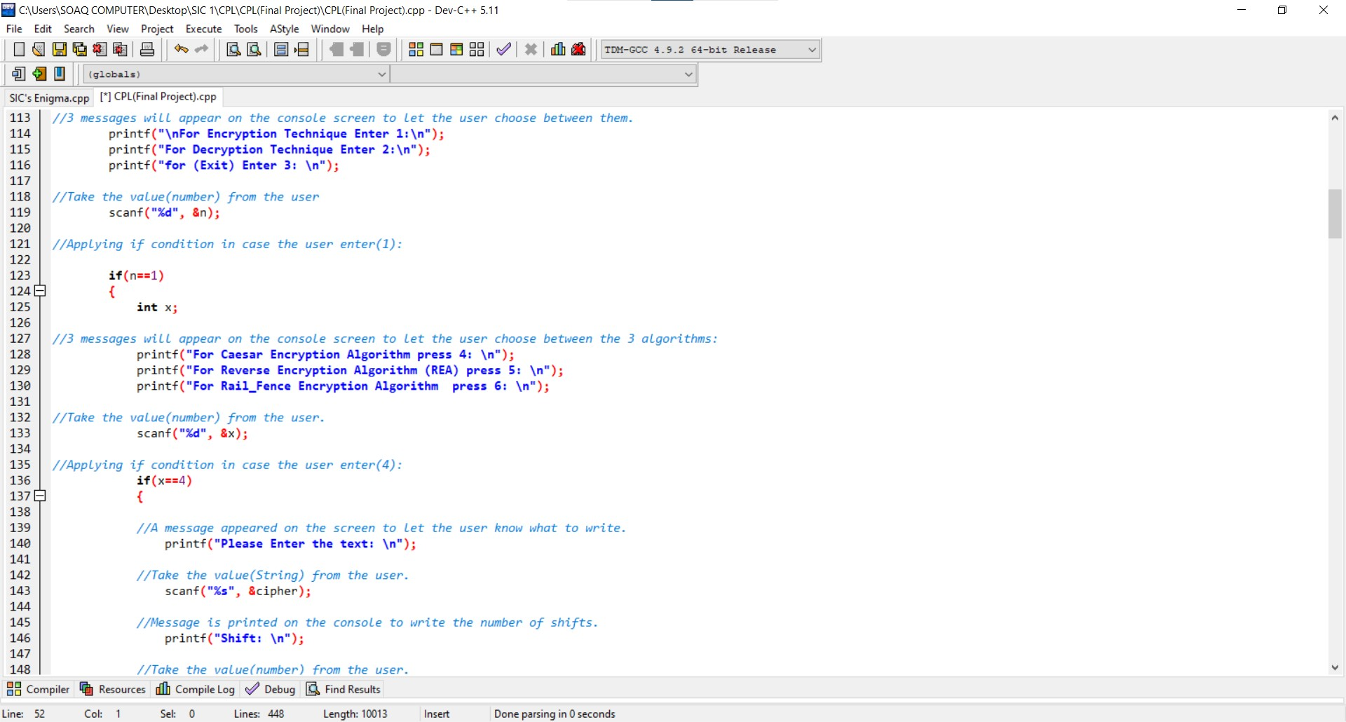

* Ask the user to choose between the **3 Algorithms.**
* Take an input from the user.

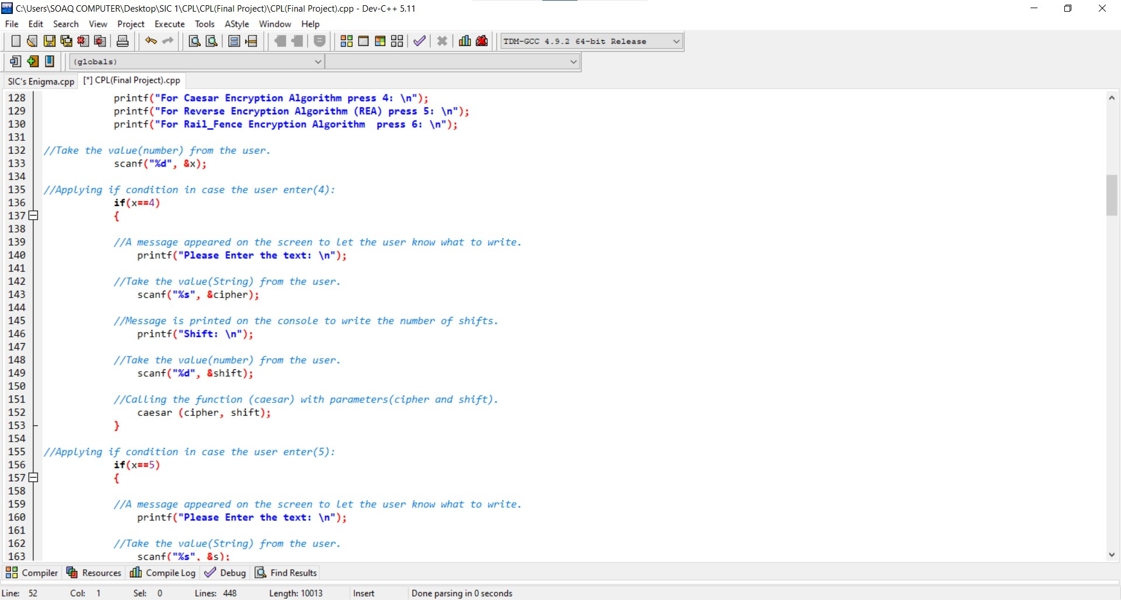

* In case the user chooses **(Caesar Encryption Algorithm).**

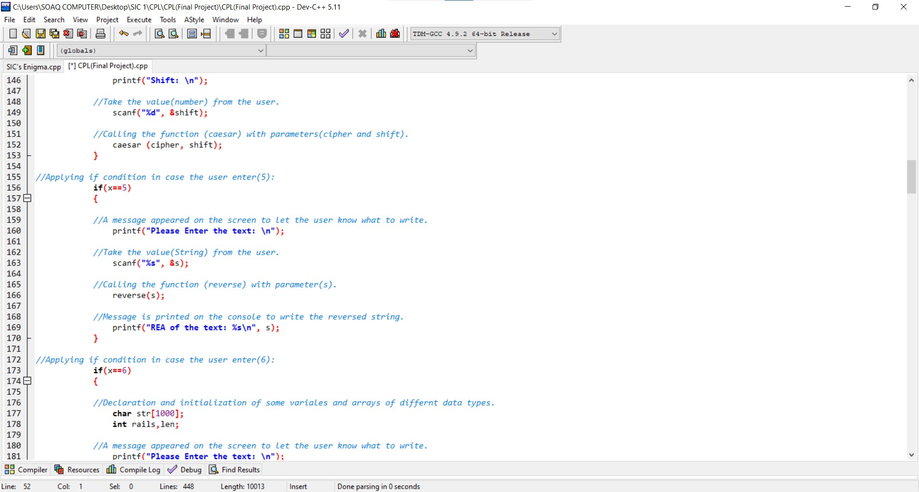

* In case the user chooses **(Reverse Encryption Algorithm (REA)).**

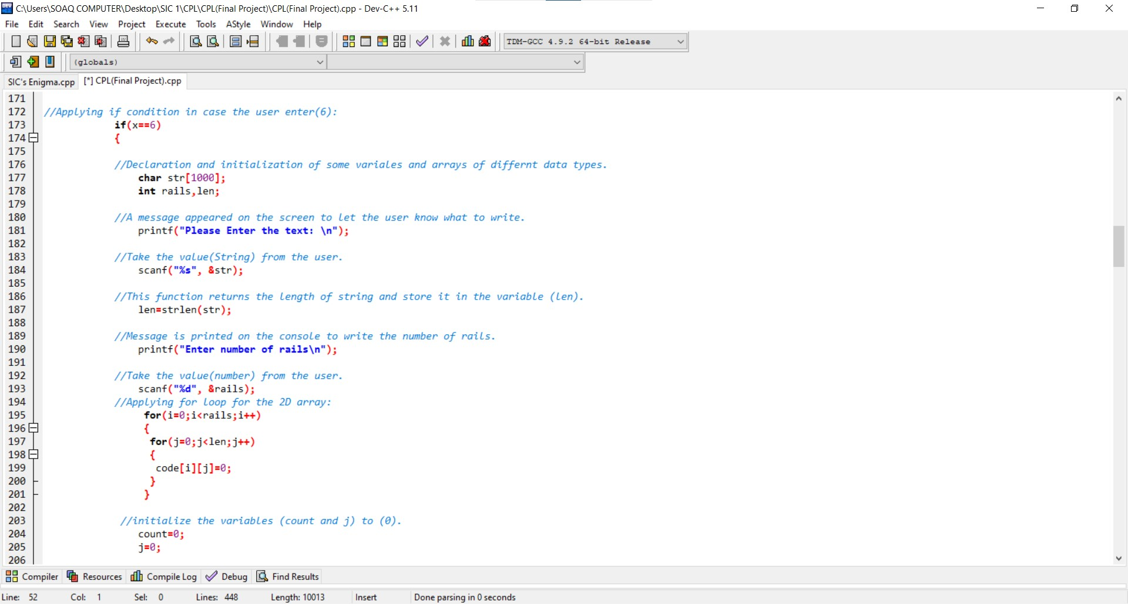

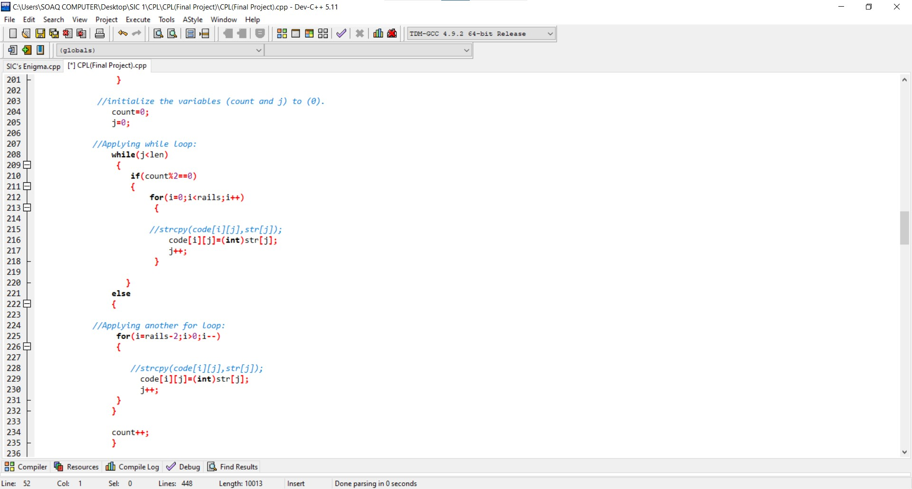

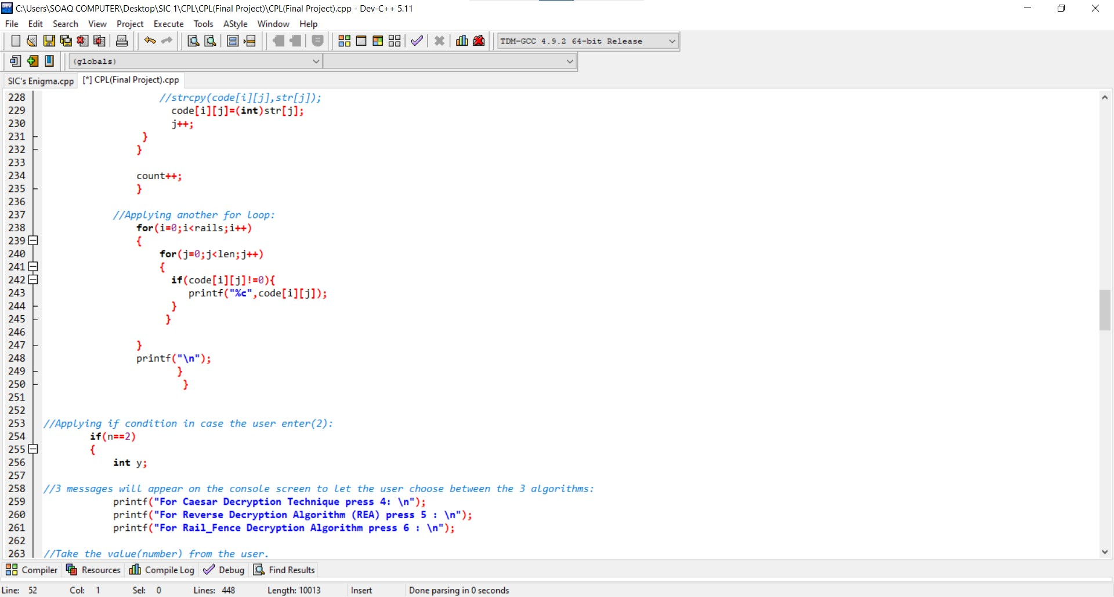

* In case the user chooses **(Rail Fence Encryption Algorithm)** which based on:
* The plain text is written downwards and diagonally on successive “rails” of an imaginary fence.
* Then moving up when the bottom rail is reached.
* When the top rail is reached, the message is written downwards again until the whole plaintext is written out.
* The message is then read off in rows.

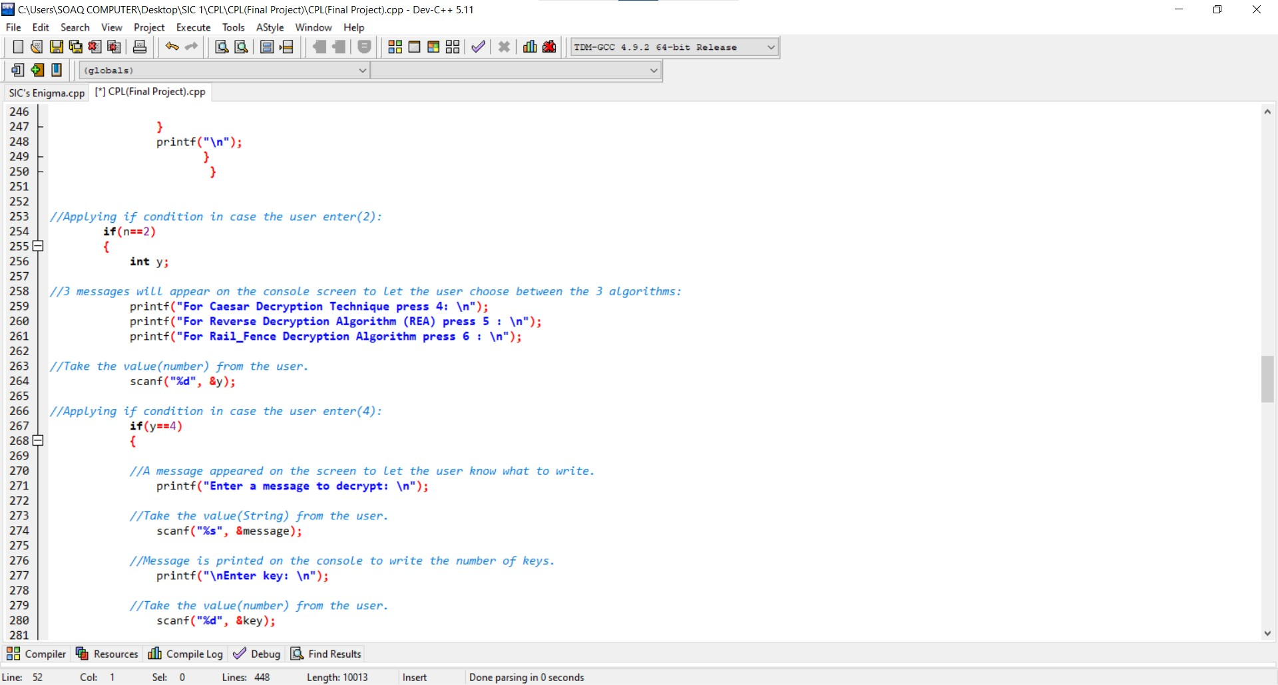

* Ask the user to choose between the **3 Algorithms.**
* Take an input from the user.

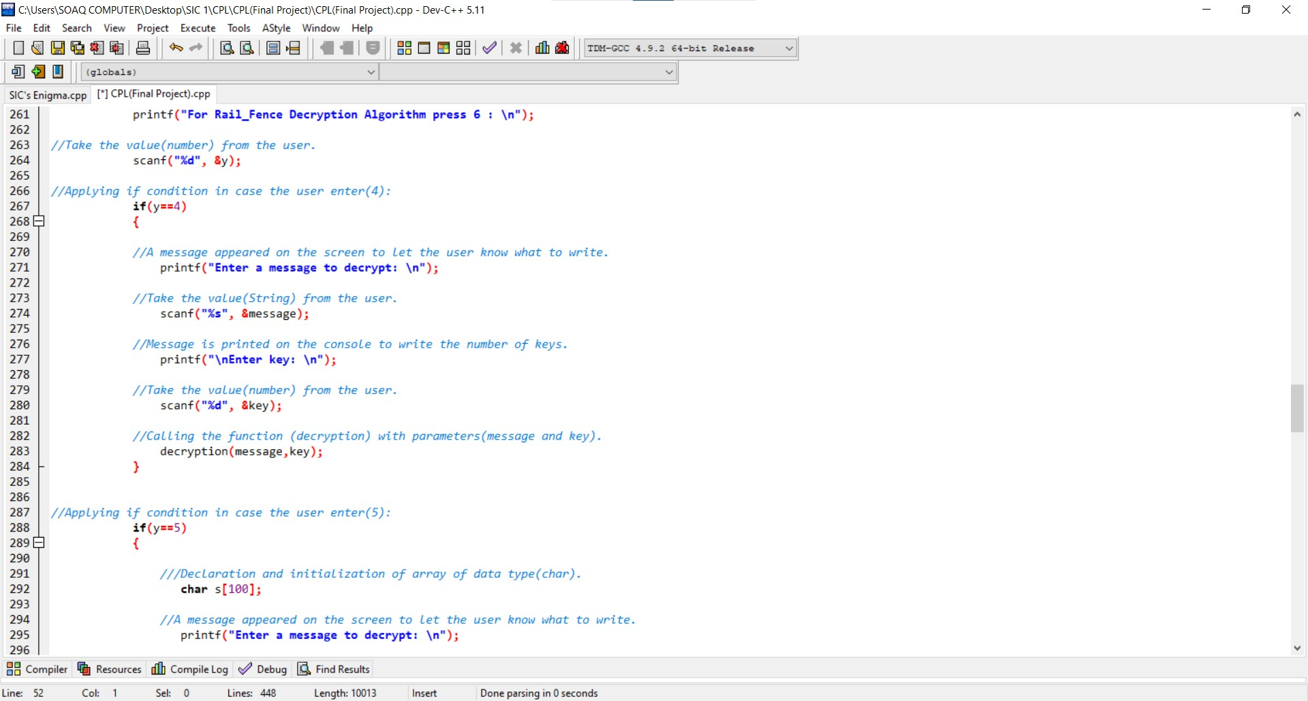

* In case the user chooses **(Caesar Decryption Algorithm).**

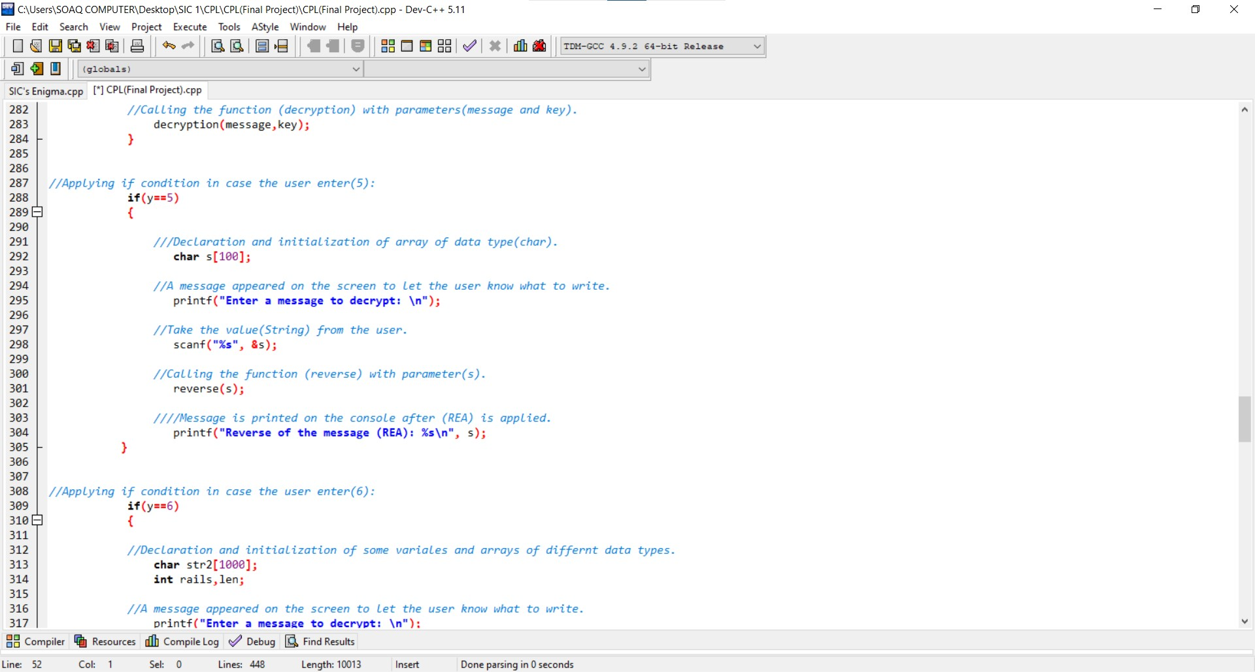

* In case the user chooses **(Reverse Decryption Algorithm (RDA)).**

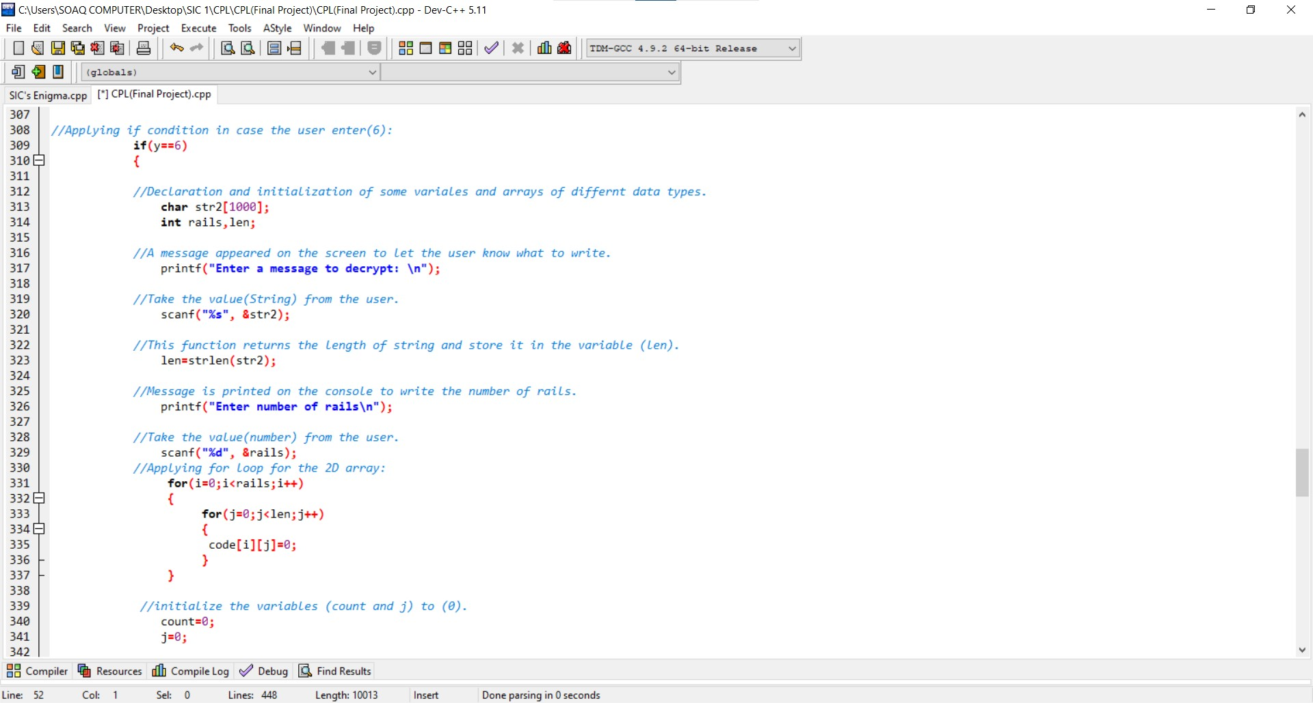

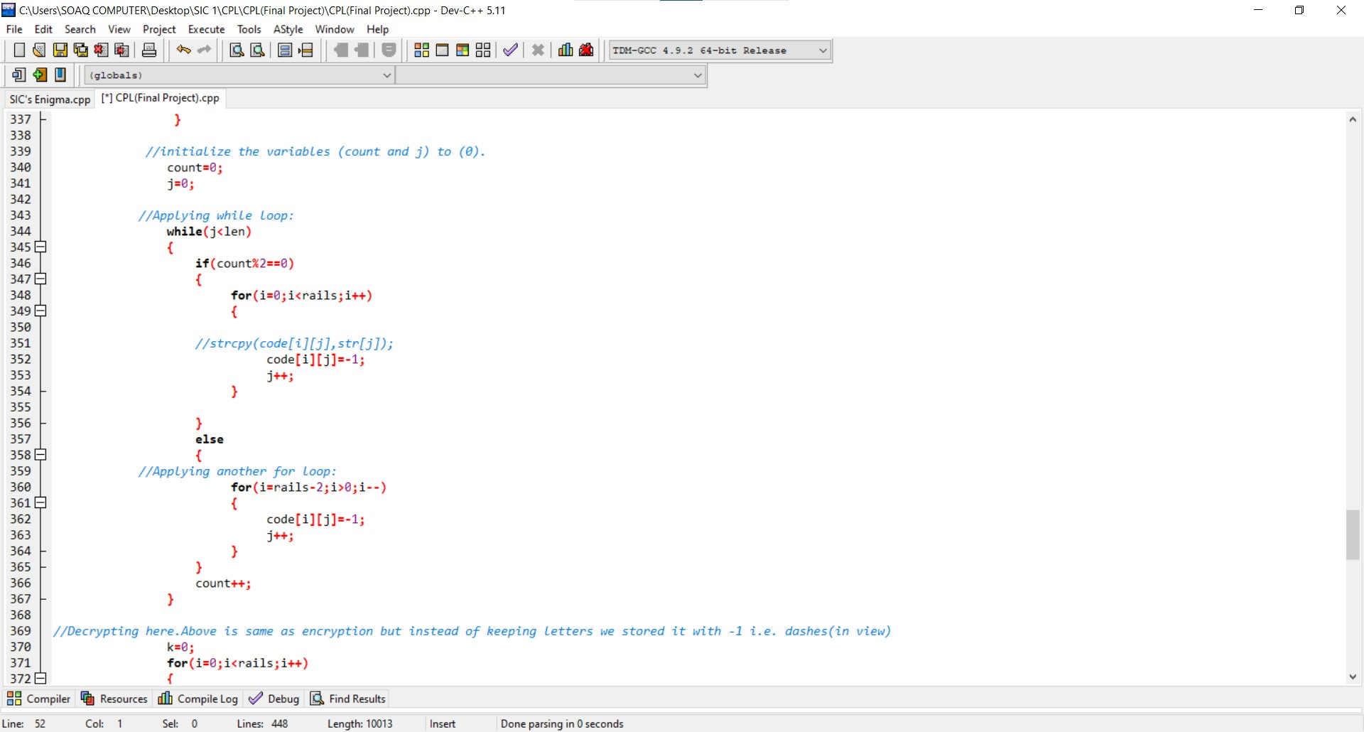

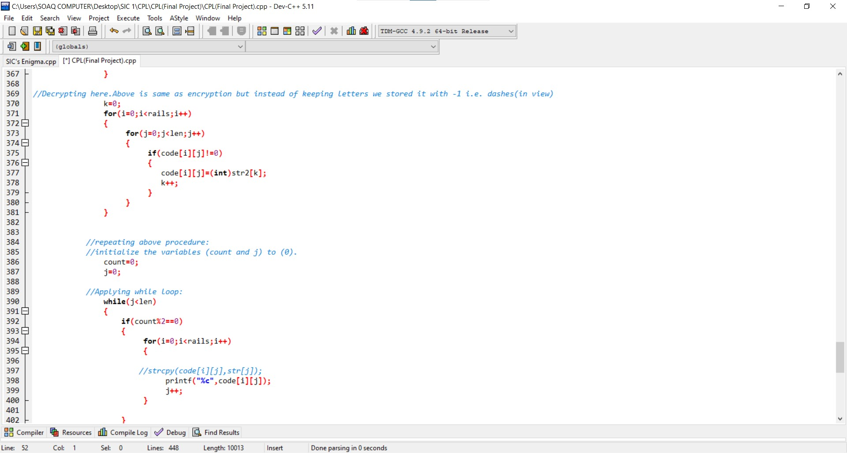

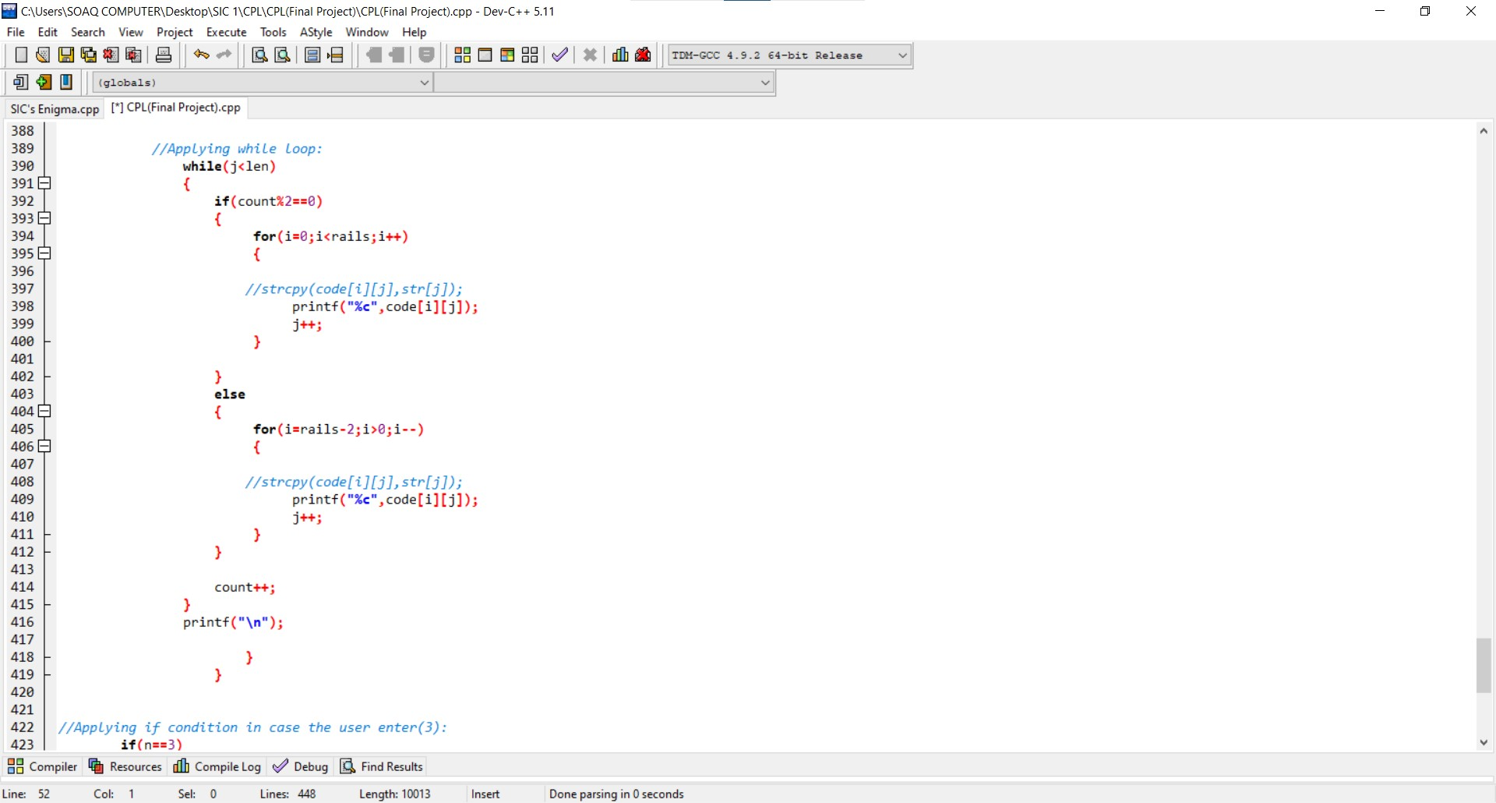

* In case the user chooses **(Rail Fence Decryption Algorithm)** which based on:
* The decryption process for the Rail Fence Cipher involves reconstructing the diagonal grid used to encrypt the message.
* We start writing the message but leaving a dash in place of the spaces yet to be occupied.
* Gradually, you can replace all the dashes with the corresponding letters and read off the plaintext from the table.
* We start by making a grid with as many rows as the key is, and as many columns as the length of the ciphertext.
* We then place the first letter in the top left square, and dashes diagonally downwards where the letters will be.
* When we get back to the top row, we place the next letter in the ciphertext.
* Continue like this across the row and start the next row when you reach the end.

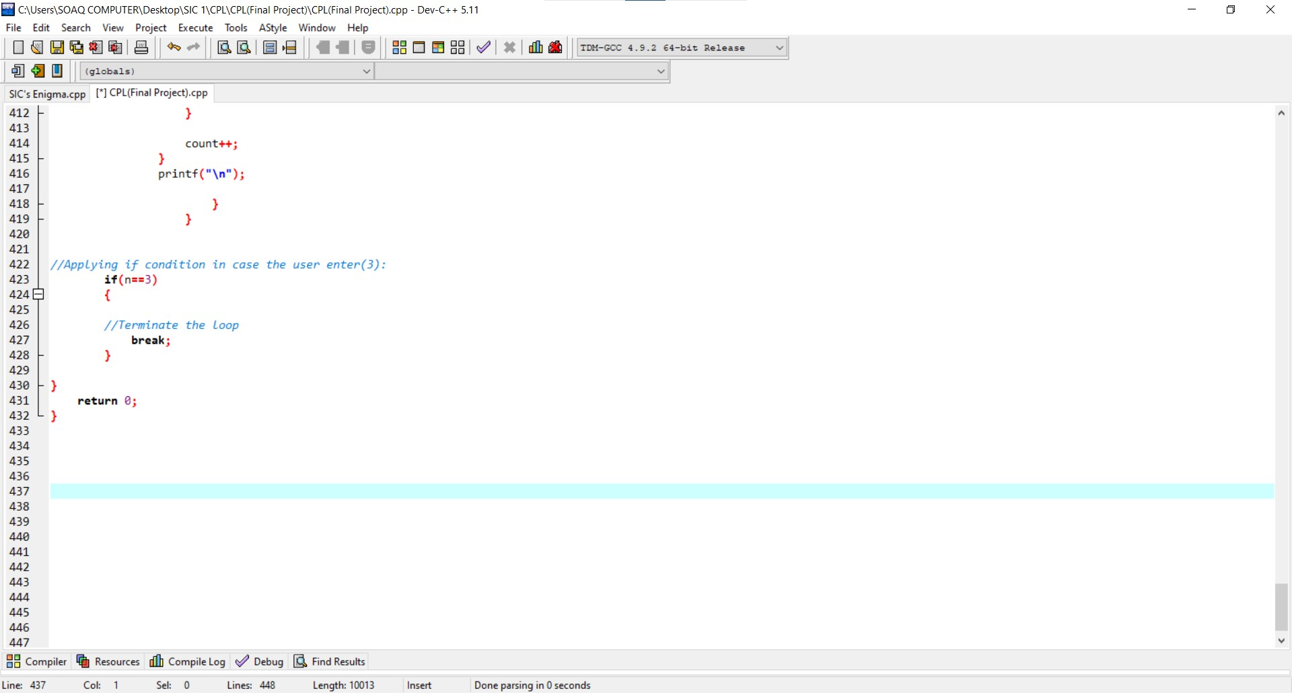

* In case the user chooses **the third choice,** then it will terminate the program.

**SIC’s Enigma program**

* This program consists of group of functions which are:
* **Caesar Function**
* **Reverse Function**
* **Decryption Function**
* **Rail fence**
* **Rail fence 2**
* **Main function**

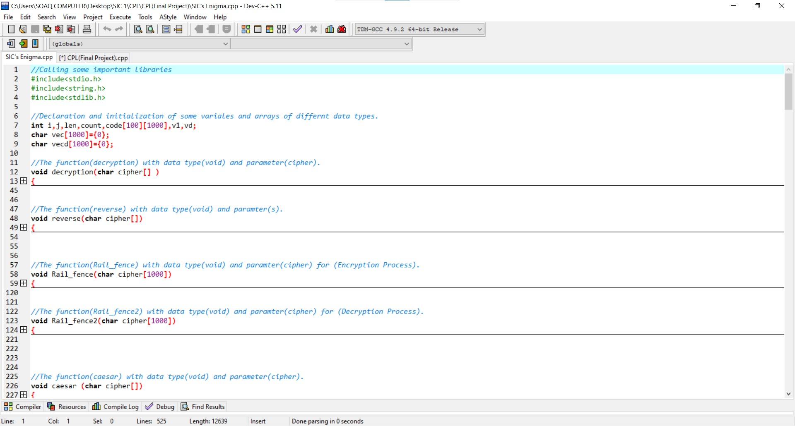

* First, we called some important libraries to help us in writing the program which are:
* **Stdio.h (Standard input output hidden library)**
* **String.h (String hidden library)**
* **Stdlib.h (Standard library (hidden))**
* **Declaration and initialization of some variables.**

**Decryption Function**

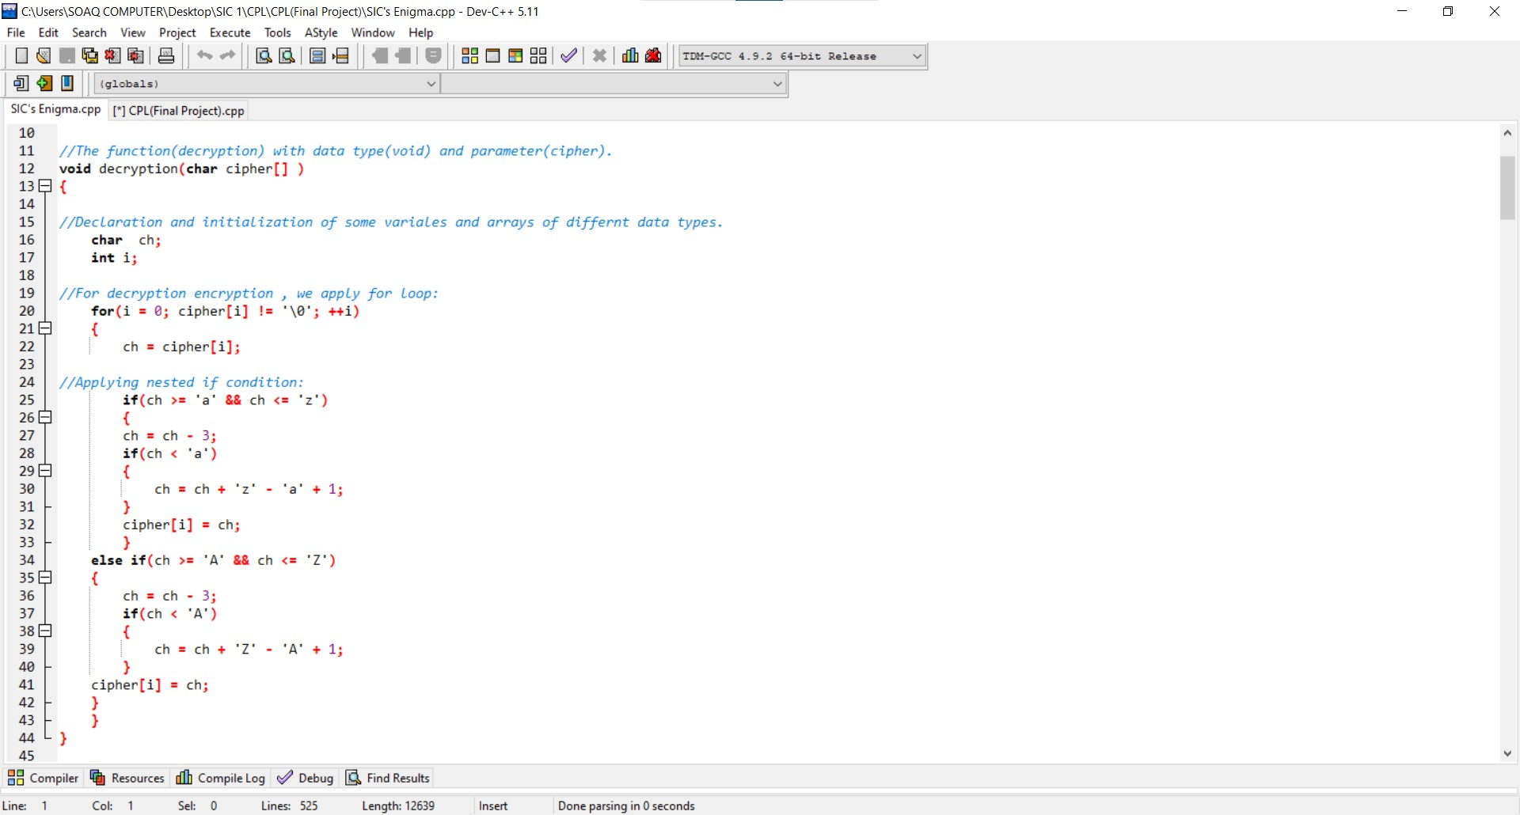

* **The Decryption function** aims to decrypt the string entered by the user by using Caesar technique.
* **Caesar technique** is based on **shifting the letters (+ or -)** and applying if conditions in some cases to make sure that the operation is correct.
* After that, the decrypted text is printed on the console screen.

**Reverse Function**

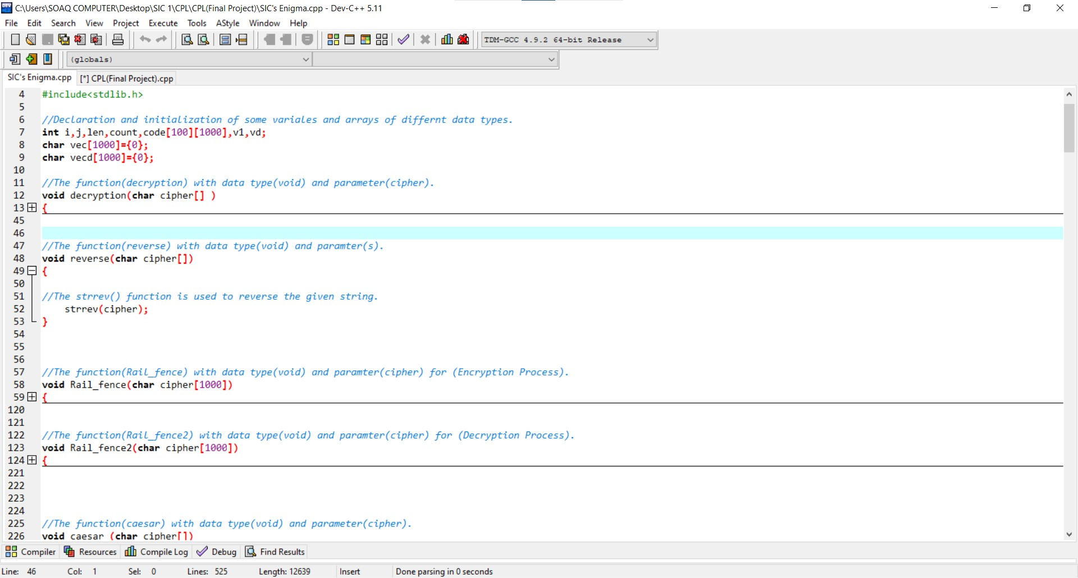

* **The Reverse function** aims to reverse the string entered by the user as one of algorithms used in **encryption and decryption techniques.**
* It reverses the array **(s).**

**Rail Fence Function**

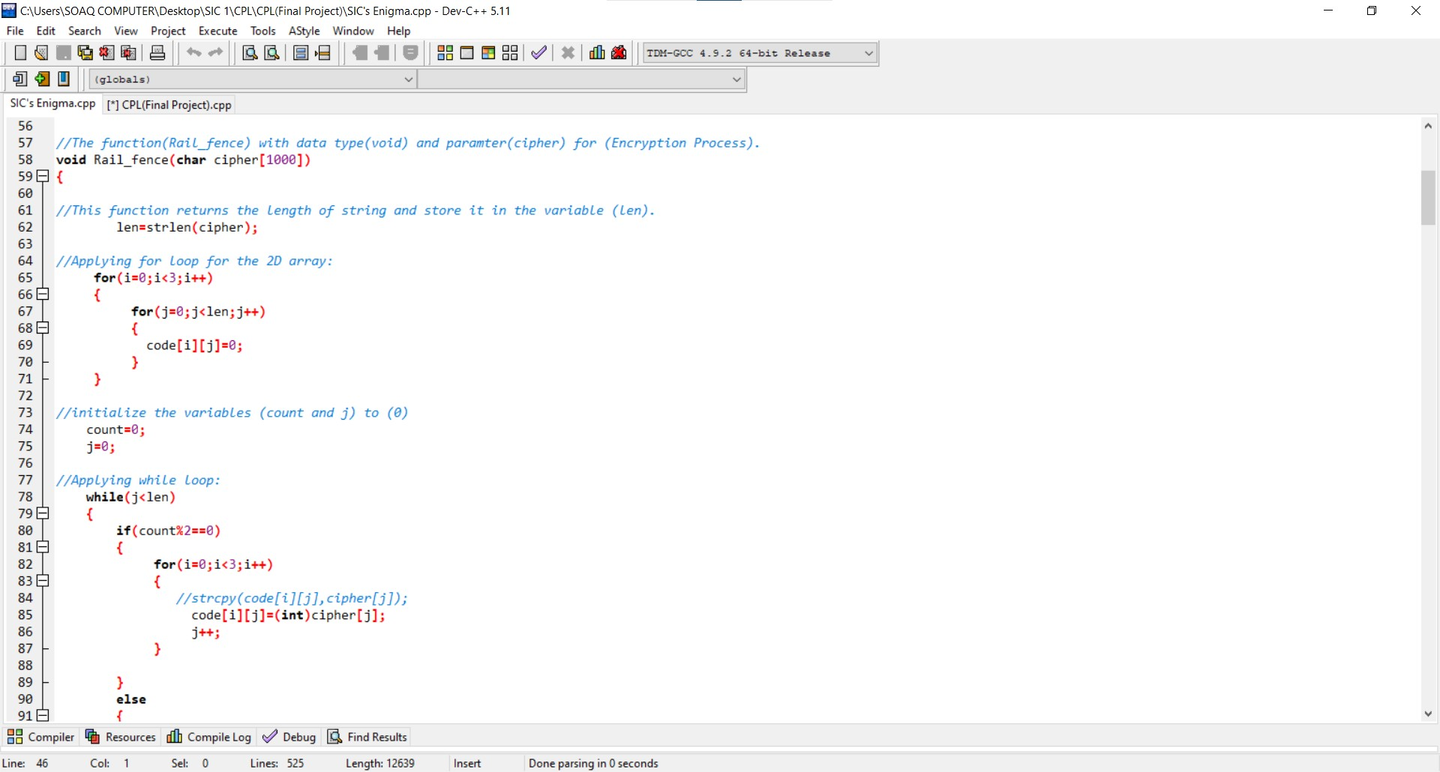

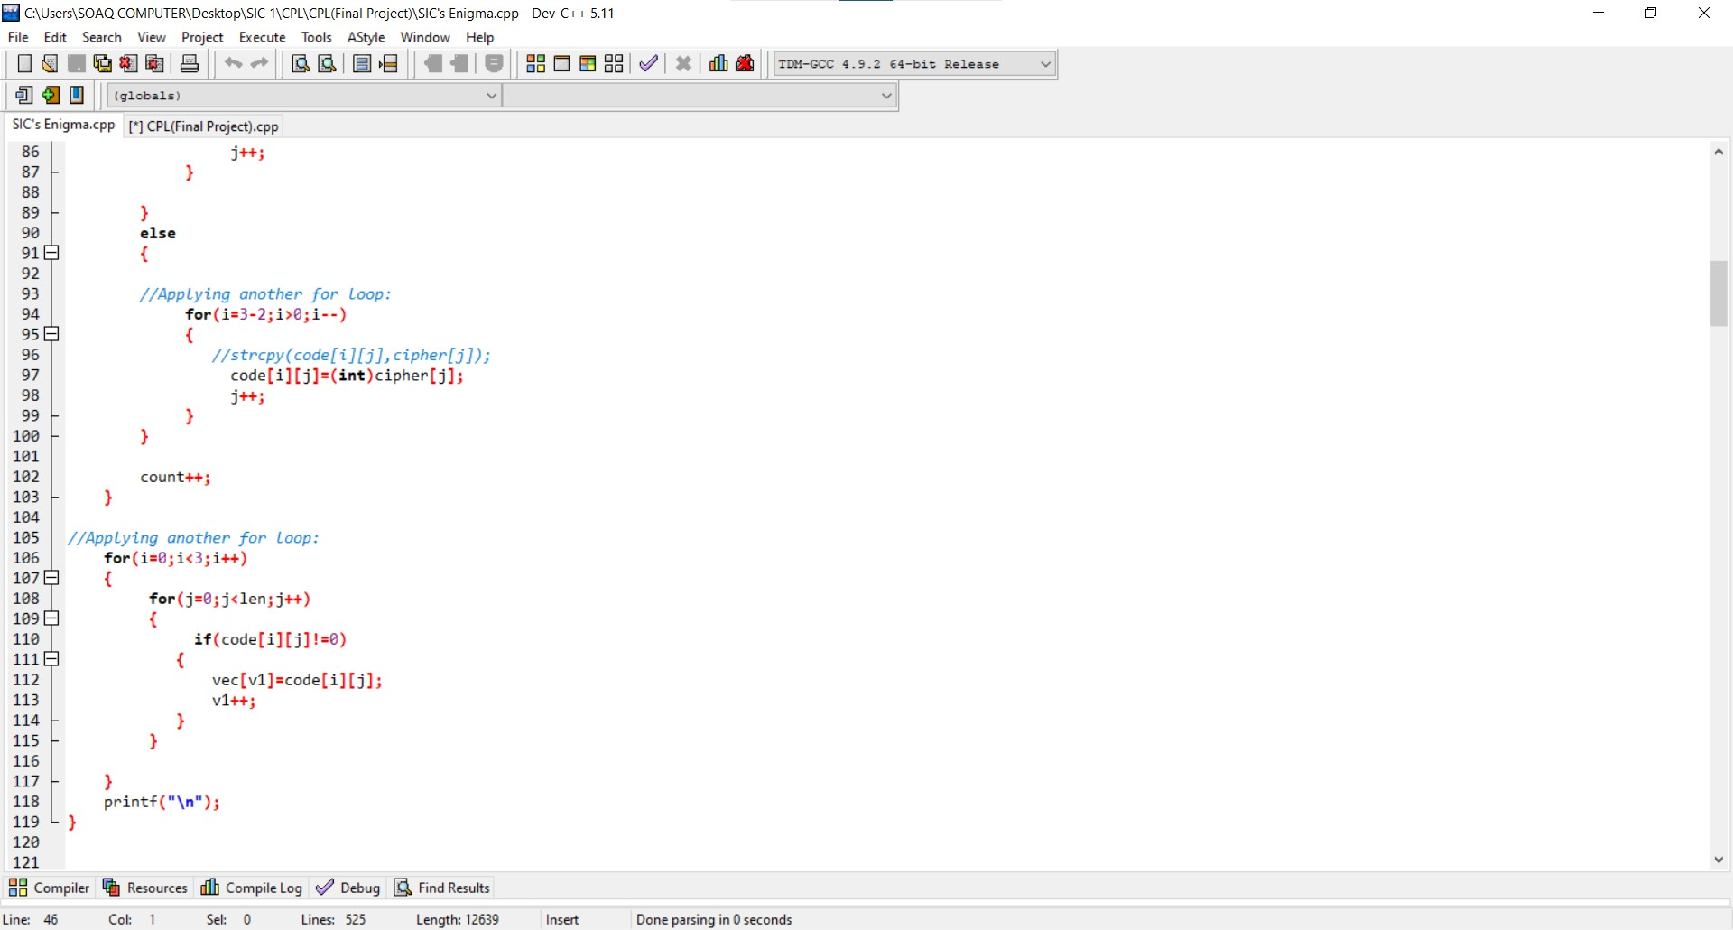

* This function aims to **(Rail Fence Encryption Algorithm)** which based on:
* The plain text is written downwards and diagonally on successive “rails” of an imaginary fence.
* Then moving up when the bottom rail is reached.
* When the top rail is reached, the message is written downwards again until the whole plaintext is written out.
* The message is then read off in rows.

**Rail Fence function 2**

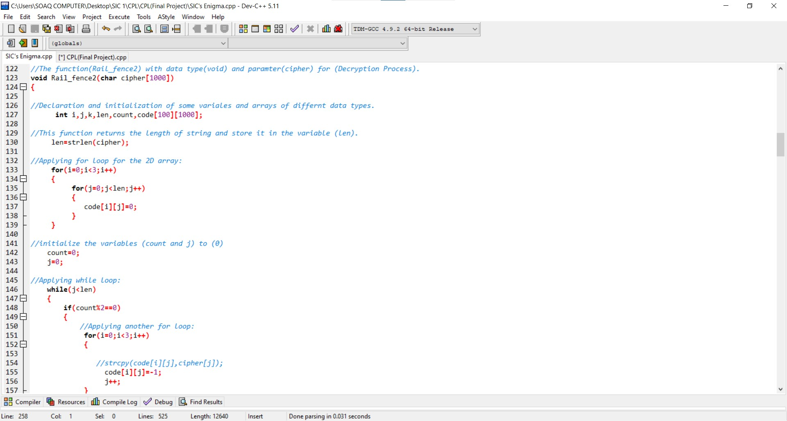

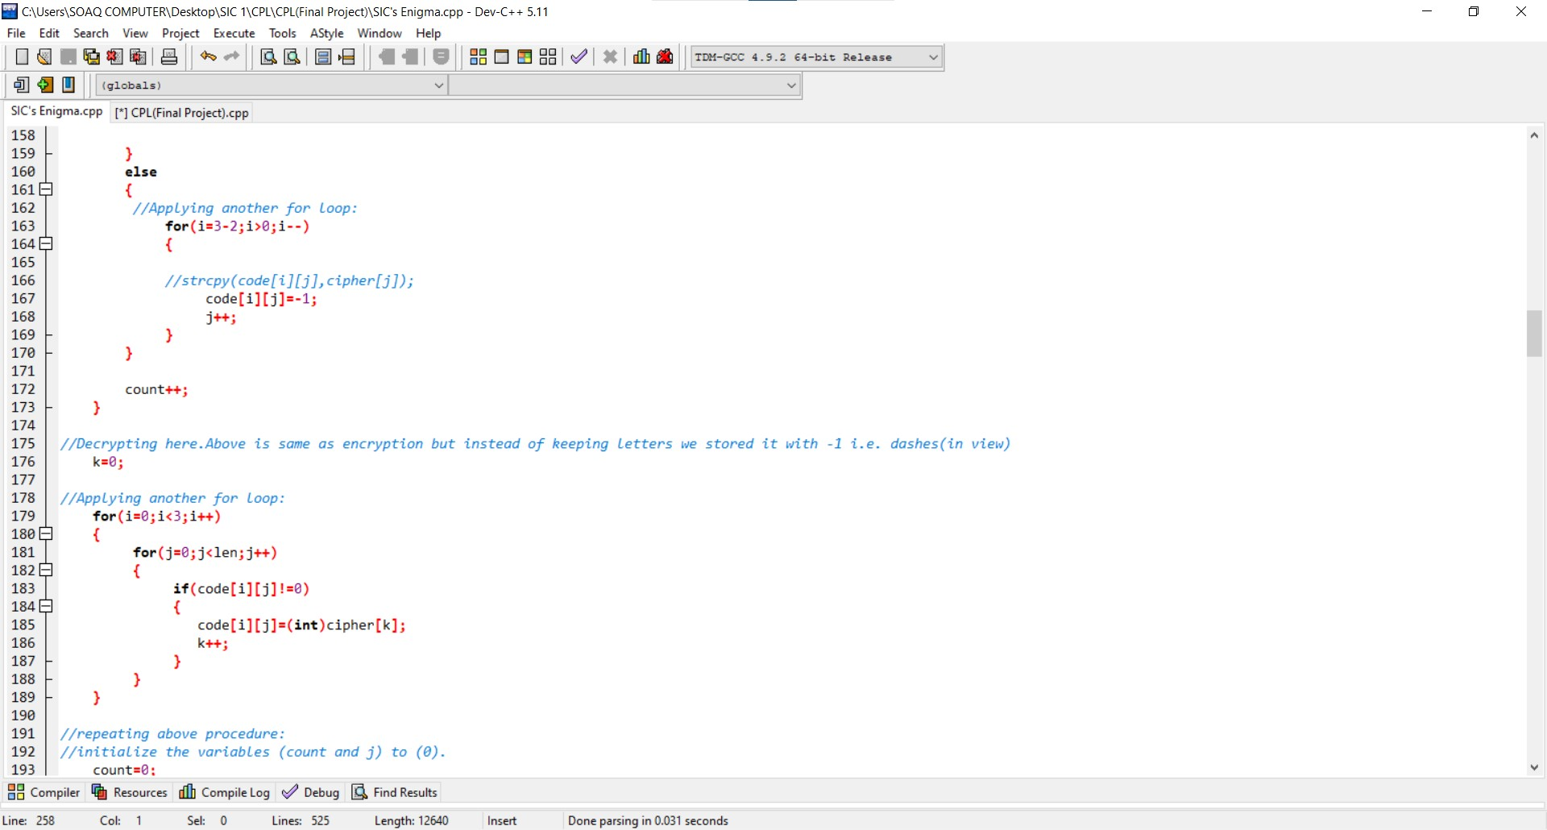

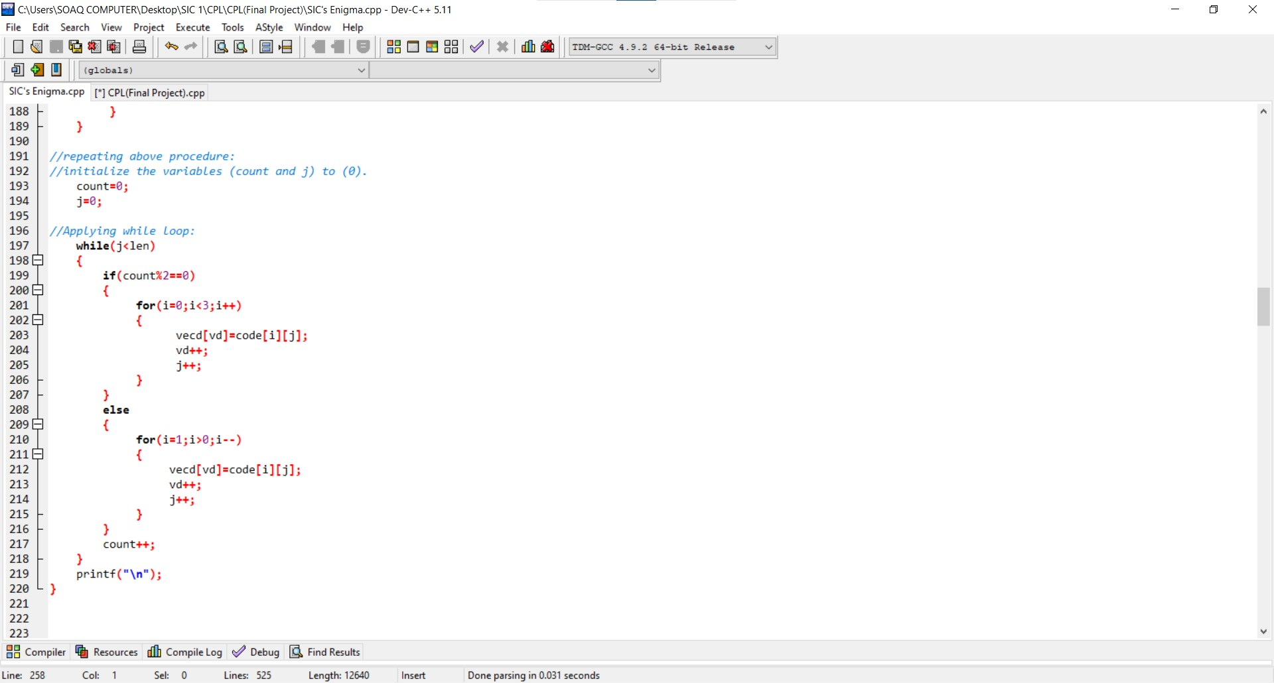

* This function aims to **(Rail Fence Decryption Algorithm)** which based on:
* The decryption process for the Rail Fence Cipher involves reconstructing the diagonal grid used to encrypt the message.
* We start writing the message but leaving a dash in place of the spaces yet to be occupied.
* Gradually, you can replace all the dashes with the corresponding letters and read off the plaintext from the table.
* We start by making a grid with as many rows as the key is, and as many columns as the length of the ciphertext.
* We then place the first letter in the top left square, and dashes diagonally downwards where the letters will be.
* When we get back to the top row, we place the next letter in the ciphertext.
* Continue like this across the row and start the next row when you reach the end.

**Main Function**

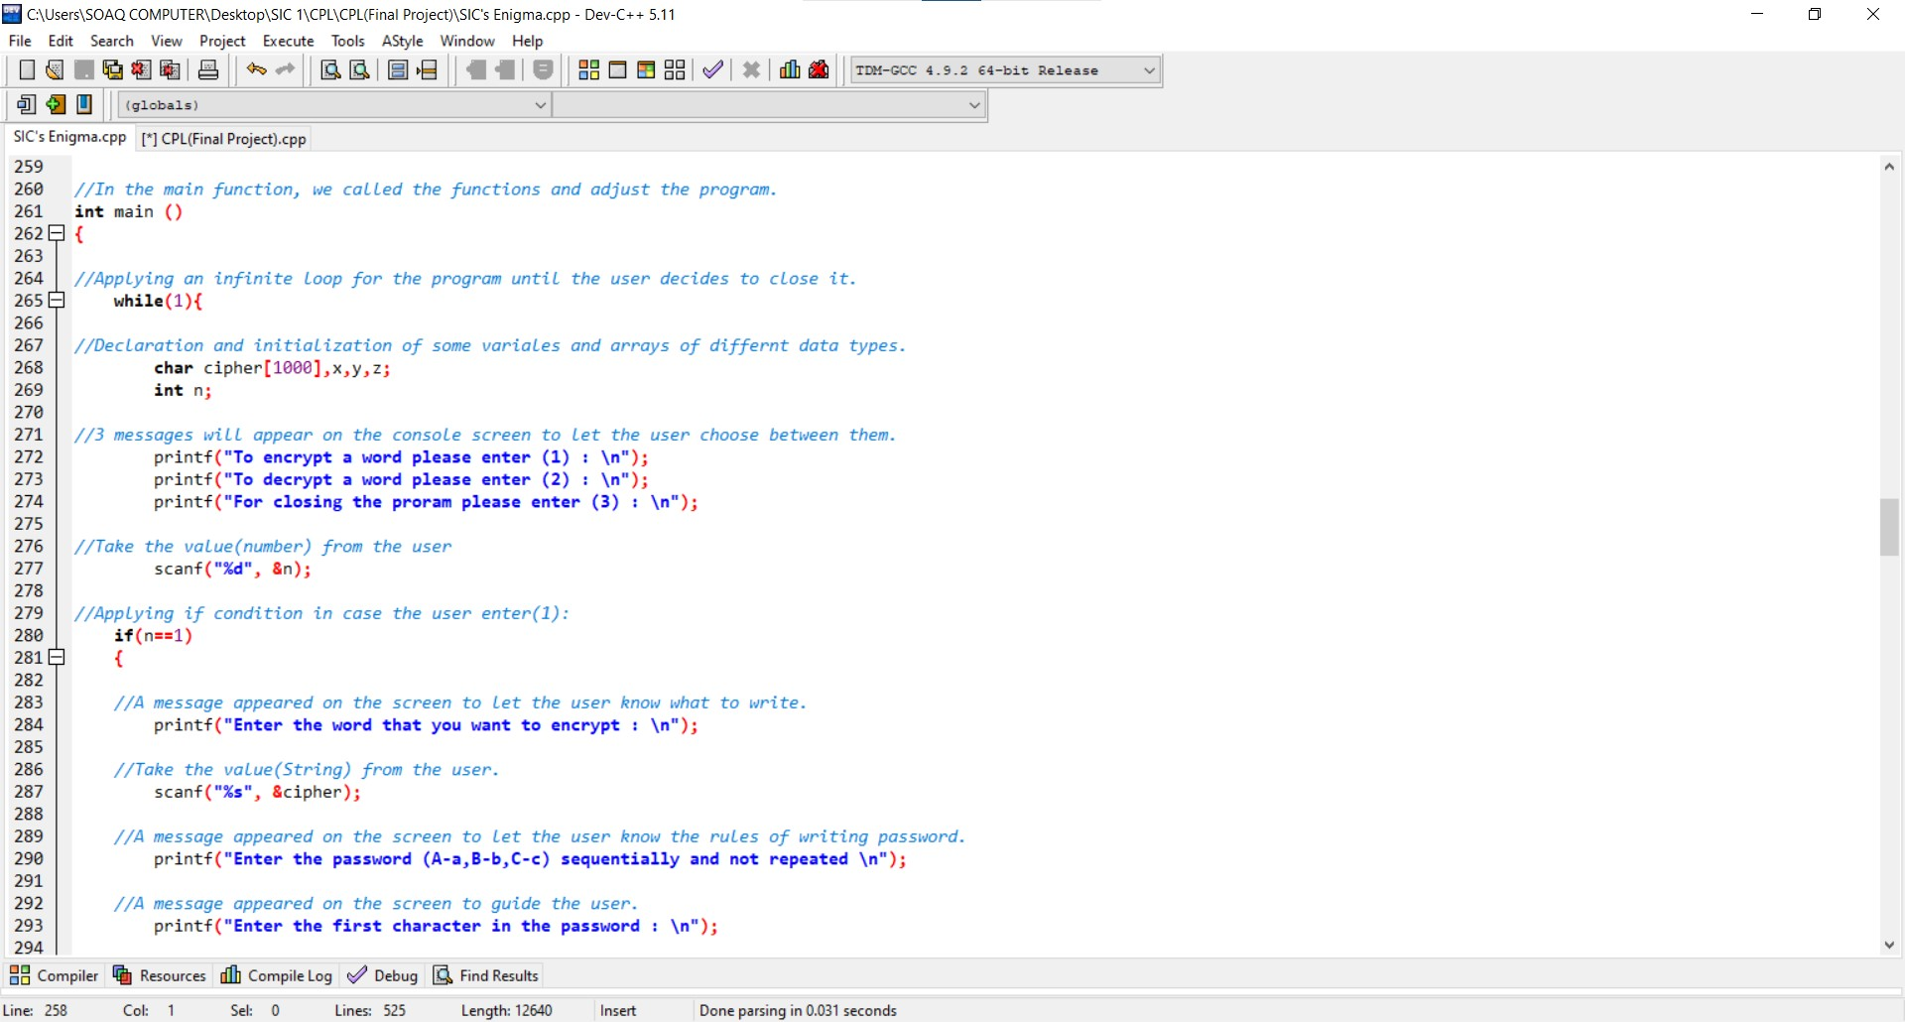

* In this function, we called the other functions and adjust the program.
* First, we apply infinite loop and inside it:
* We declared and initialized some variables.
* Print some messages.
* Take an input from the user.

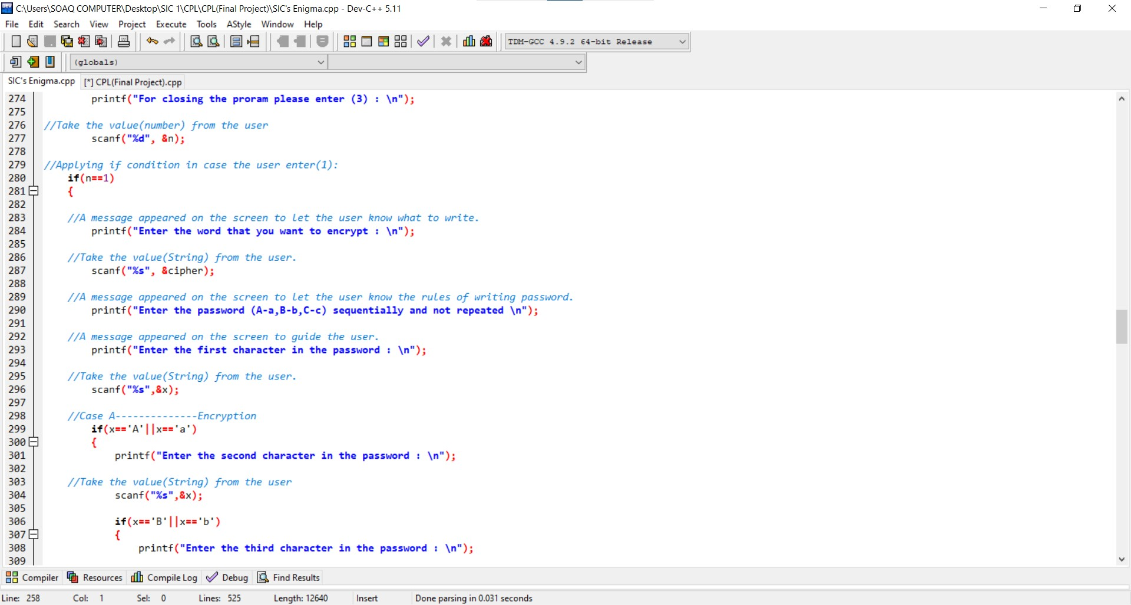

* In case the user chooses **(Encryption Algorithm).**

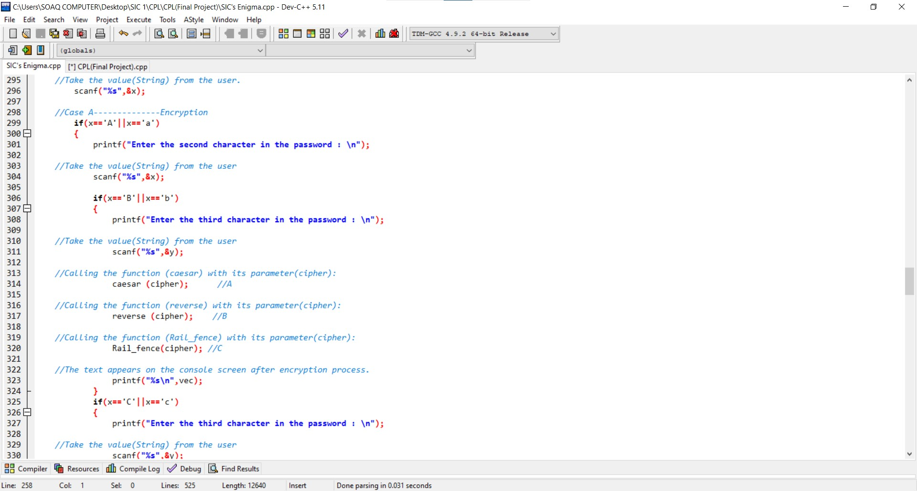

* In case the user chooses (A) then (B) then (C):
* **First calling the (Caesar) function.**
* **Then calling (reverse) function.**
* **Then calling (Rail fence) function.**

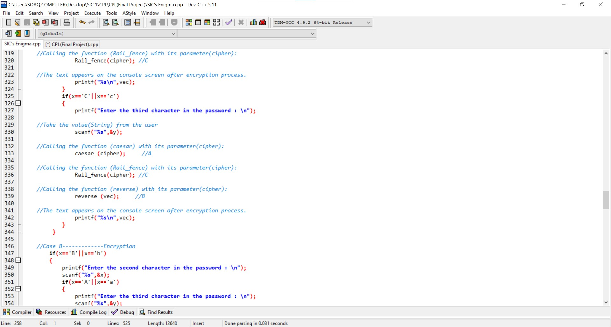

* In case the user chooses (A) then (C) then (B):
* **First calling the (Caesar) function.**
* **Then calling (Rail fence) function.**
* **Then calling (Reverse) function.**

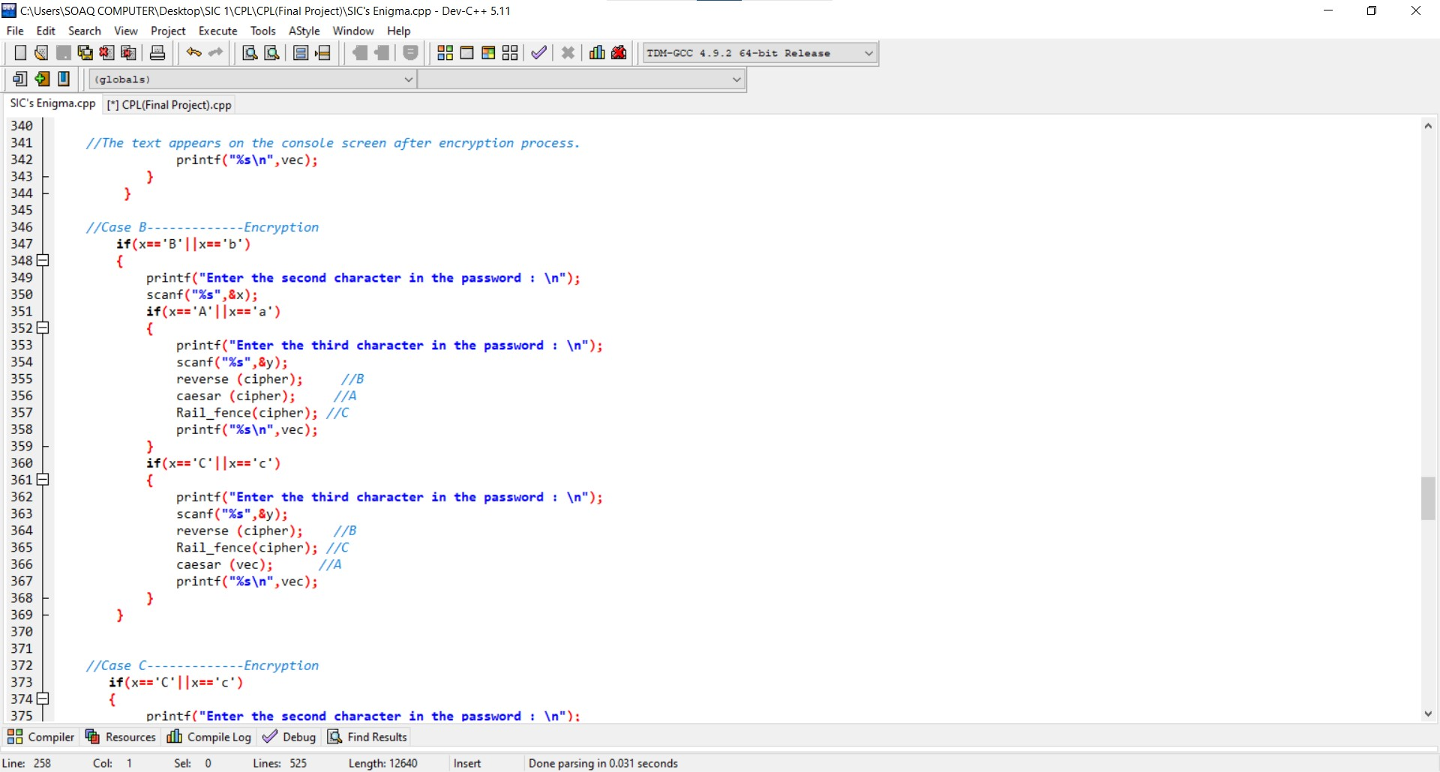

* In case the user chooses (B) then (A) then (C):
* **First calling the (Reverse) function.**
* **Then calling (Caesar) function.**
* **Then calling (Rail fence) function.**
* In case the user chooses (B) then (C) then (A):
* **First calling the (Reverse) function.**
* **Then calling (Rail fence) function.**
* **Then calling (Caesar) function.**

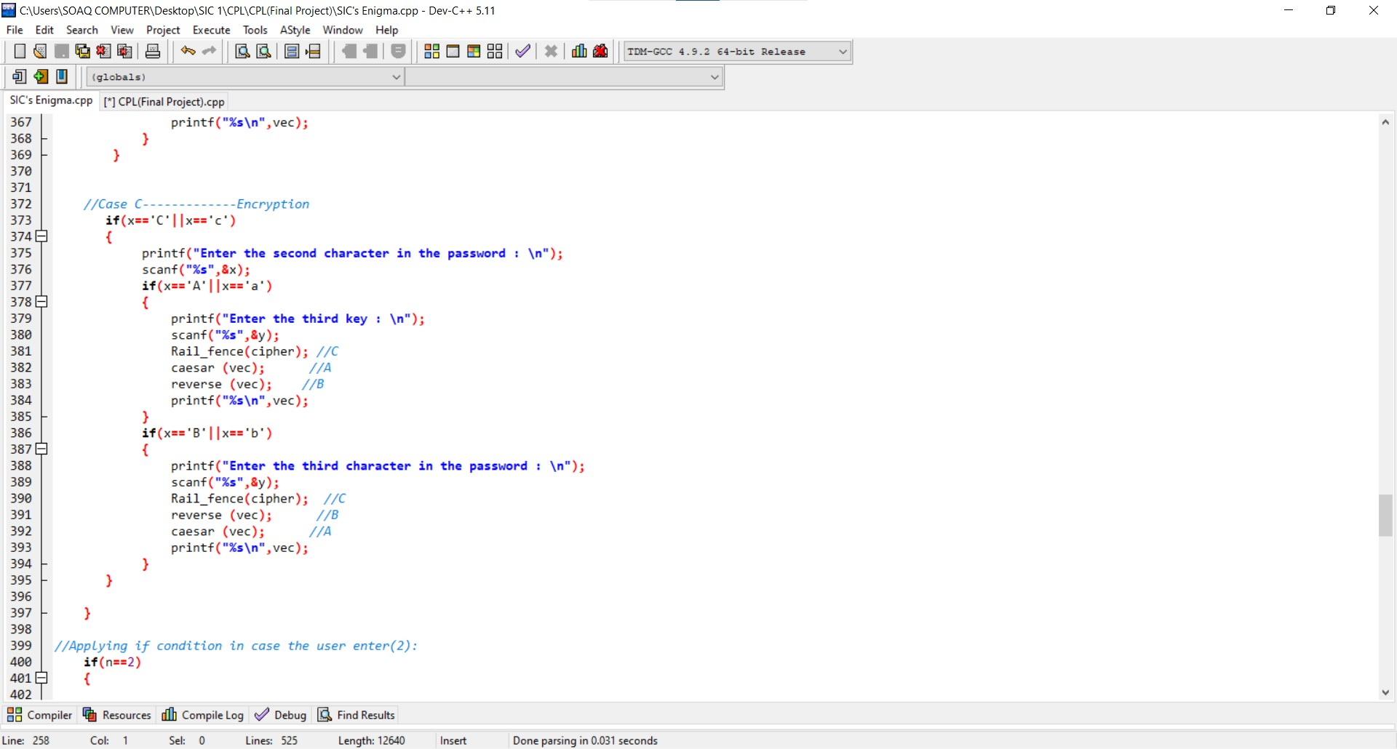

* In case the user chooses (C) then (A) then (B):
* **First calling the (Rail fence) function.**
* **Then calling (Caesar) function.**
* **Then calling (Reverse) function.**
* In case the user chooses (C) then (B) then (A):
* **First calling the (Rail fence) function.**
* **Then calling (Reverse) function.**
* **Then calling (Caesar) function.**

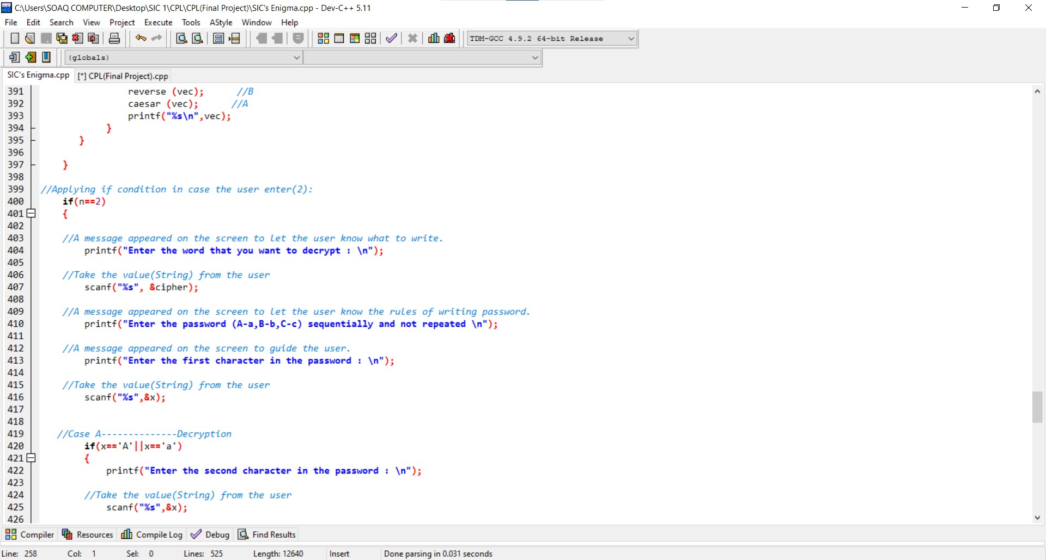

* In case the user chooses **(Decryption Algorithm).**

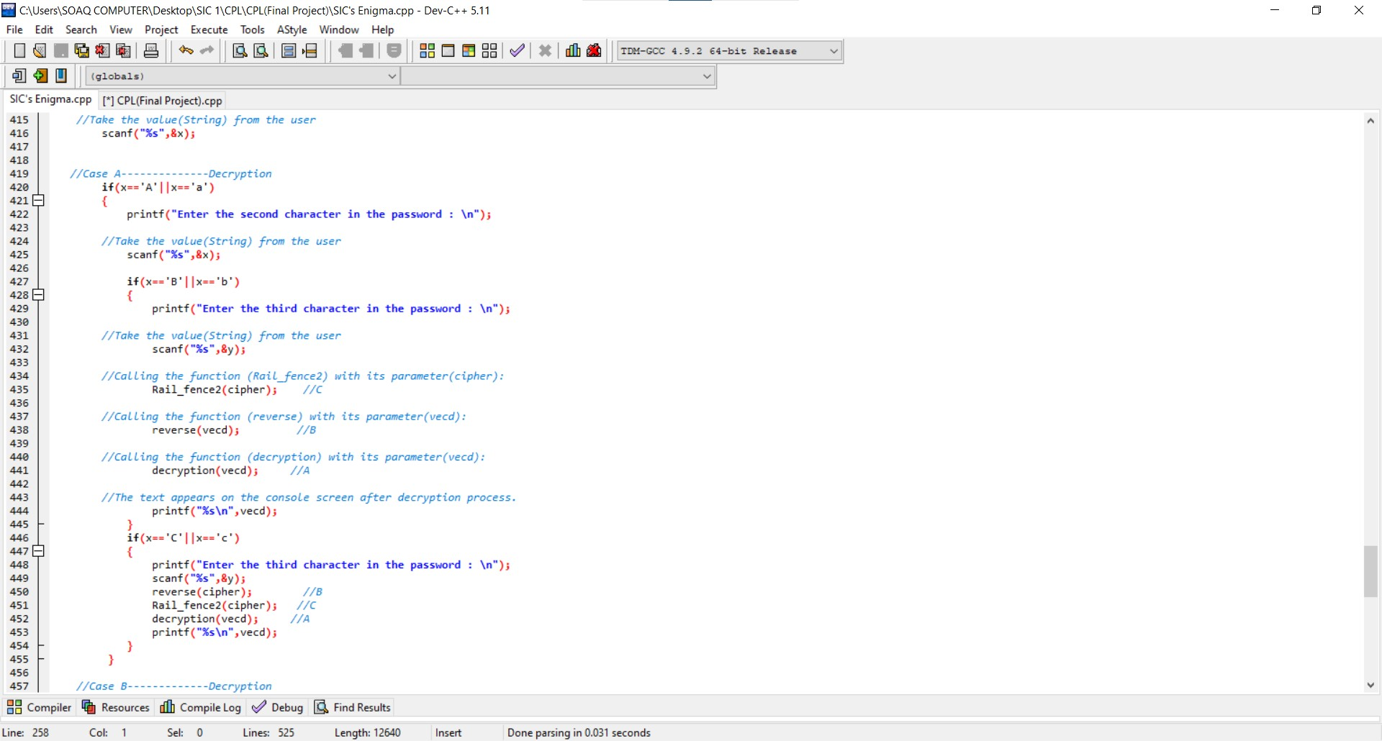

* In case the user chooses (C) then (B) then (A):
* **First calling the (Rail fence2) function.**
* **Then calling (Reverse) function.**
* **Then calling (Decryption) function.**
* In case the user chooses (B) then (C) then (A):
* **First calling the (Reverse) function.**
* **Then calling (Rail fence2) function.**
* **Then calling (Decryption) function.**

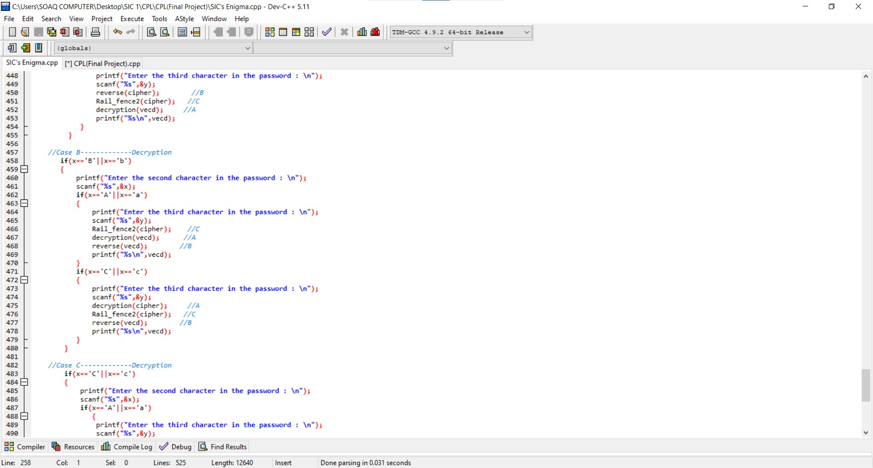

* In case the user chooses (C) then (A) then (B):
* **First calling the (Rail fence2) function.**
* **Then calling (Decryption) function.**
* **Then calling (Reverse) function.**
* In case the user chooses (A) then (C) then (B):
* **First calling the (Decryption) function.**
* **Then calling (Rail fence2) function.**
* **Then calling (Reverse) function.**

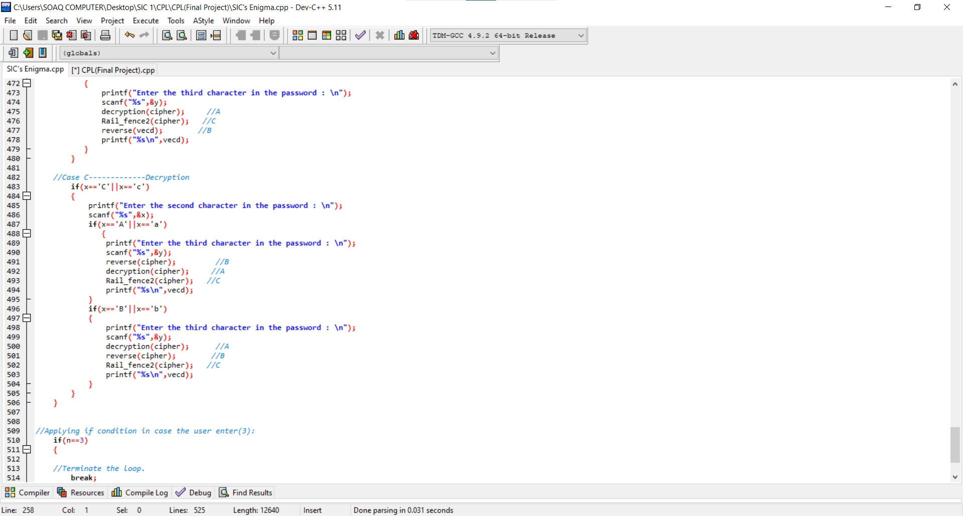

* In case the user chooses (B) then (A) then (C):
* **First calling the (Reverse) function.**
* **Then calling (Decryption) function.**
* **Then calling (Rail fence2) function.**
* In case the user chooses (A) then (B) then (C):
* **First calling the (Decryption) function.**
* **Then calling (Reverse) function.**
* **Then calling (Rail fence2) function.**

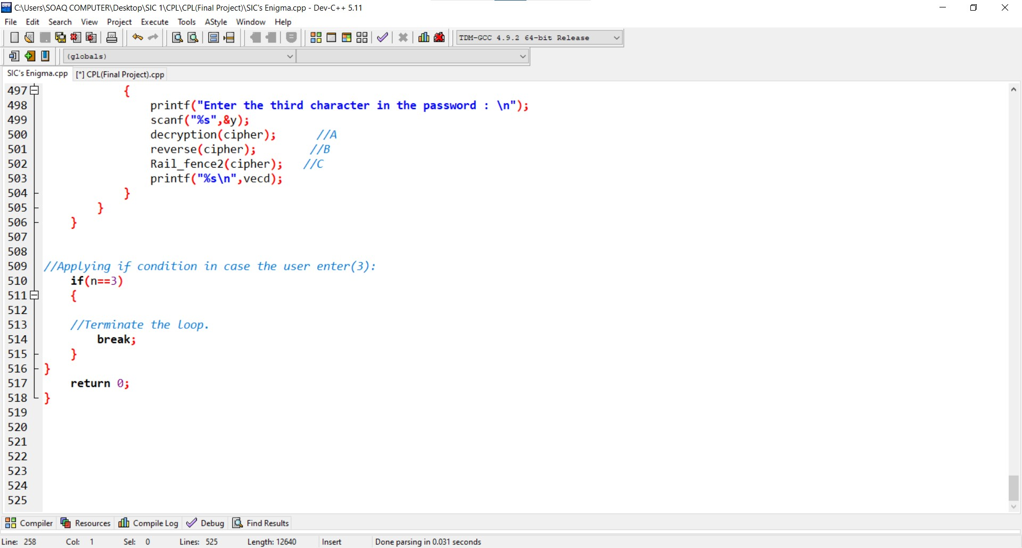

* In case the user chooses **the third choice,** then it will terminate the program

Samsung Innovation Campus

CPL

final project

(**Multi-choice encryption and decryption program** && **SIC’s Enigma**)

